Monday
Children solve the first question this using the ‘counting on’ method using objects to represent the oranges (see video).

‘I had 10 oranges in my basket, and I added 5 more. How many oranges do I have now?’ Write this as a number sentence.
So the number sentence would be:
10+5= 15

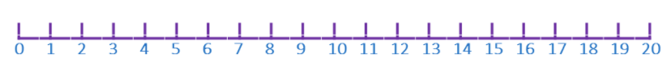
Solve 9+6 using the number line
9+6=

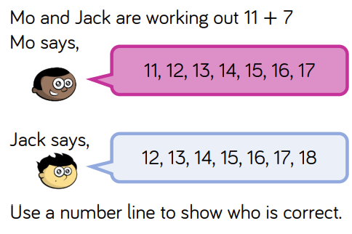

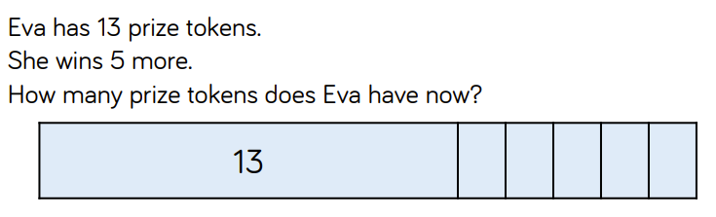

Extension
Maths Magician is solving an addition question and does not know whether to start at the bigger or smaller number. What do you think is easier? Write a sentence below to explain.

Answer: Children should say it is easier to start at the bigger number as there is less to count on. This makes it quicker and easier.

