Following the success of our Christmas Rainbow Raffle we have decided to hold another one for Easter. We will use the same safety messages as before to ensure everything is Covid secure.
Deadlines dates
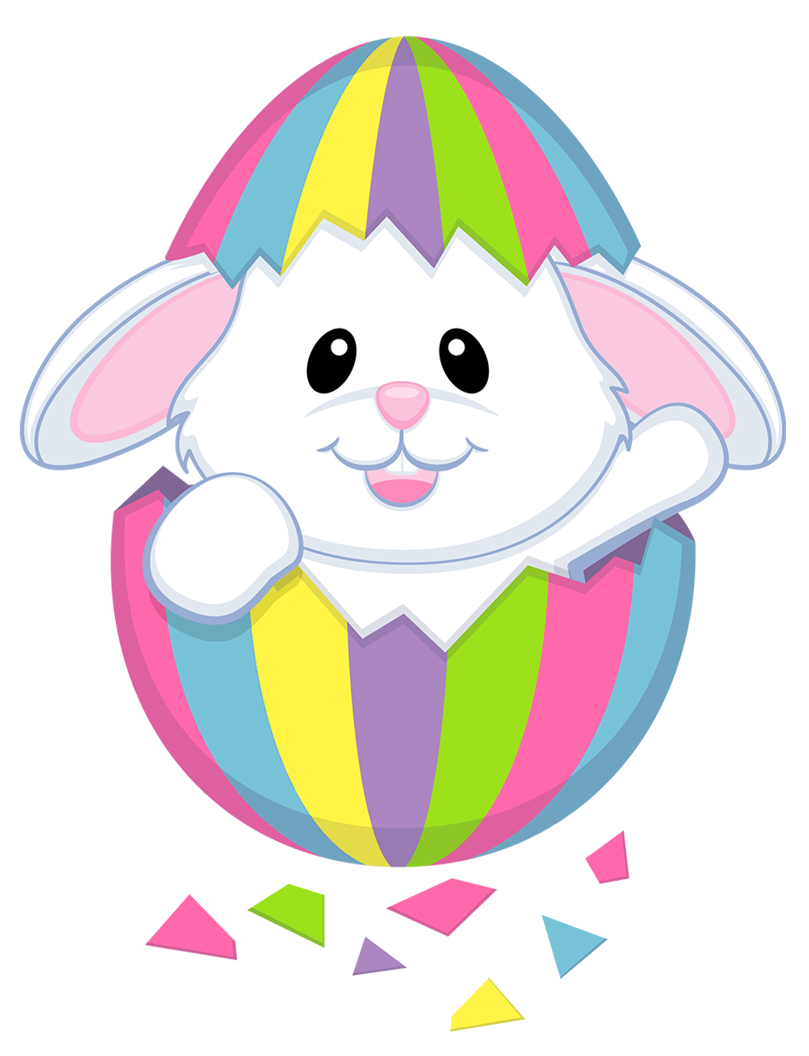Hamper items between 15th March & 19th March 2021
Ticket money in by Wednesday 24th March
Raffle draw will be recorded and posted onto our website the evening of Thursday 25th March
Hamper collection from the office from 26th March
What colour am I?
Each class has been allocated a colour:
Ruby – Purple Nursery- Blue
Pearl – Green Emerald – Yellow/Gold
Sapphire - Orange Topaz - White/Silver
Diamond - Red

What do I bring? If they can, we are asking each child to donate one item in their class colour for the hampers. You can donate more if you wish.
There are many different things you could choose but if you’re stuck, here are a few ideas: Drinks, chocolates/confectionary, biscuits/cake, Easter Eggs, toiletries, toys/books/games, craft, stationery, household items, decoration or novelty gifts.
Feel free to use your imagination!
Items must be new, non-refrigerated, with a minimum 2-month use by date and we’re sorry but we can’t accept homemade items.
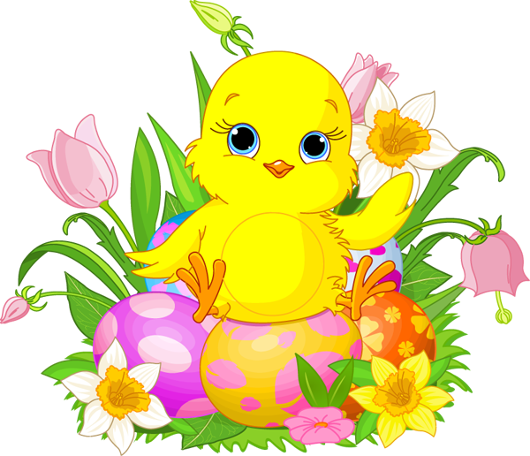EASTER RAINBOW RAFFLE
What are the Coronavirus safety measures?
The hamper and items will remain in the classroom untouched until collected by a member of staff for the finishing touches to be made and to allow a further period of quarantine.
Virtual ticket numbers will be sent following receipt of payment to minimise cross-contamination.
How do I get the raffle tickets?
Tickets are £1 per strip.
Please complete the form at the bottom of this letter and send into school with your child with, preferably the correct money.
The office will then contact you with your virtual raffle numbers rather than sending them home to you.

Mrs Futers will make the draw for the winning tickets on Thursday 25th March and this will be posted on our website. The winners will also be contacted by text.

The hampers will be ready to collect from the office from Friday 26th March.

Childs Name______________________________________ Childs Class__________________________________
Number of Tickets Required__________ I have enclosed £_______________
Contact Name and Number for winners to be notified on___________________________________________________________________________________________

