Tuesday 27th April 2021
Dear Mums, Dads and Carers,

We will be completing a Number day on Friday 14th May. This special day will celebrate the importance of maths and numbers. It will include a range of fun number based activities to complete whilst fundraising for our school.
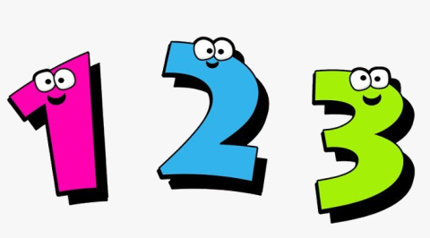
We will be fundraising by:
- Dressing up in a number themed costume. This can be as creative as you like and could include for example, a dice, clock, ruler, number fairy, calculator, calendar, decorating a t-shirt with numbers etc. All adults and children are invited to dress up, bringing a 50p donation for this in a sealed envelope.

- Using maths skills to: measure ingredients, read temperatures from a recipe and time how long food must be cooked for whilst baking edible treats. These will then be available for your child to enjoy and eat at snack time for 50p. (Each class will provide further details on this). If your child has any allergies please speak to their class teacher so an alternative can be provided.

- Completing a sponsored Number hunt. Each year group will be timed for a set amount of minutes to find 100 hidden numbers. See how many sponsors you can get to encourage you! Complete the sponsor form and return it with your money in a sealed envelope by Friday 14th May.

- Running a beat the teacher challenge with Mrs Cole and Mrs Futers. Can any children complete addition and subtraction questions quicker than the Headteacher and Assistant Headteacher?

Thank you for your continued support.

Yours sincerely,

Mrs C Cole
Assistant Headteacher

Number hunt sponsorship form: will you and your class be able to find the hidden100 numbers in the set time?

Child’s name: _____________________________________

Child’s class: ______________________________
Name: | Sponsorship amount | Date collected:

