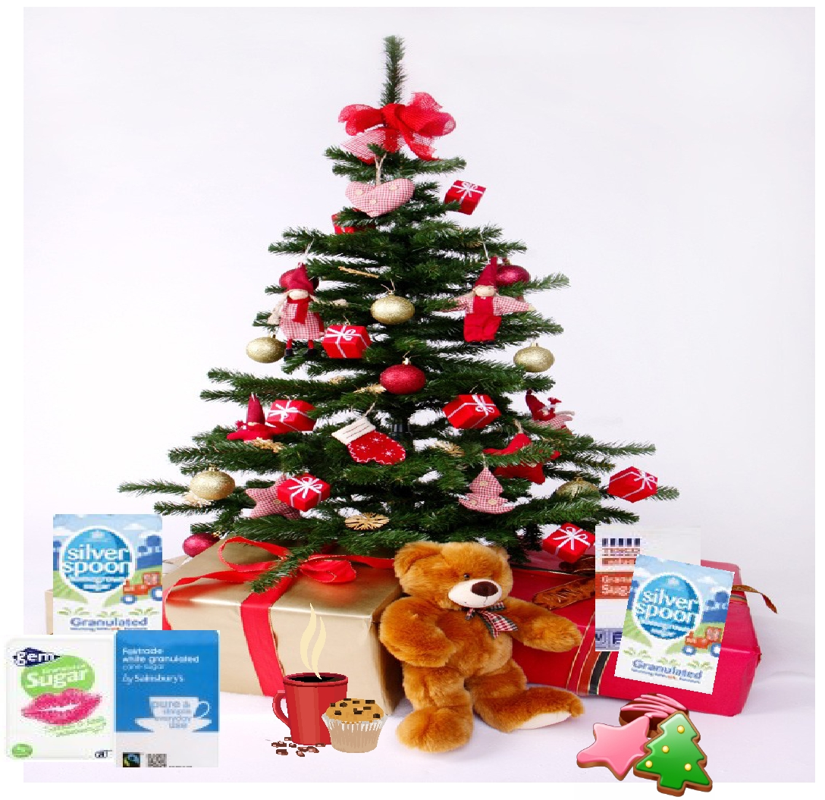
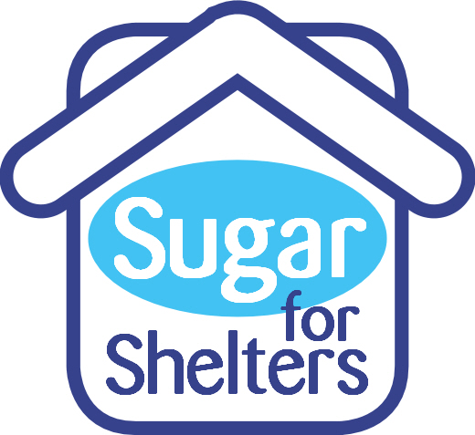
Dear Parent/Carer,

This Christmas our school will be collecting sugar to support a local appeal, "Sugar for Shelters".

Every year Norfolk and Suffolk school children donate sugar to help homeless and needy people throughout the county at Christmas. (The total last year was an amazing 6 tonnes!).

- Sugar for Shelters is a part of the Buckingham Emergency Food Appeal (BEFA). This NORFOLK farm based Christmas Food Charity, founded by Norfolk farmer Mike Buckingham in 1985, provides the food for more than 5000 Christmas dinners.

- Schools help Sugar for Shelters by collecting bags of sugar for the homeless, needy and vulnerable in local shelters.

- Huge amounts of sugar are needed and make a REAL difference in Shelters and Food Kitchens throughout Norfolk and Suffolk in the cold days of winter and particularly over Christmas.

- Collecting sugar is simple and affordable and helps children focus on the spirit of giving at Christmas.

- British Sugar will match the schools' donations of every kilo of their brand of sugar
(Silver Spoon) up to 2000kg !

We do hope that you and your child can help the homeless
and needy by bringing in a bag of sugar to school by
8th December 2021.

Thank you in anticipation for supporting the Appeal
at this special time of the year.

Yours sincerely ,

Christmas School Sugar Collection
For the homeless and hungry, families in crisis, and those seeking refuge from domestic violence in East Anglia.

