2021-2024
‘So whether you eat or drink or whatever you do, do it all for the glory of God’.
(1 Corinthians 10:31)

Introduction
Dereham Church Infant School and Nursery is committed to being a healthy school and to promote the health and wellbeing of the school community. As part of this we aim to create a supportive environment that helps our children make healthier food choices, as well as educating and equipping children with the skills to enable them to achieve a healthier diet now, and in later life.

Other relevant policies
• PSHE
• RSHE
• Physical Education

Aim
• To ensure that all aspects of food and nutrition in the school helps promote the health and well-being of the whole school community

Objectives
• To ensure that food provided across the school day is consistent with our aim
• To ensure that food and nutrition information across the curriculum, and in extra-curricular activities, and wrap around care, is consistent and up-to-date.
• To ensure that the whole school community is involved in the implementation of this policy

Settings for Food Policy Across the School Day
Snack time – Main School and Nursery
- Morning breaktime:
The children have an option to purchase on a half-termly basis a piece of toast and butter, milk or an orange/apple drink from the kitchen. A fruit or vegetable option may be brought in from home, which is sent in a named bag/ container. No other snacks from home may be brought in.

- Afternoon fruit/vegetable option.

As part of the Fruit and Vegetable Scheme for Schools, the children are offered a portion of fruit or vegetable in the afternoon.

- Snack time – Nursery
Nursery provides a milk/juice/water option with fruit.

- School lunches
Regular review of the provision of school meals by staff, supported by Norfolk County Council (NCC) ensures that meals are in line with county council policy.
Parents/carers are kept informed of our provision of healthy meals through information from Norse.

- Packed lunches
• The School Lunch Box policy was developed with staff, children and parents /carers and implemented in September 2008. It is reviewed every 3 years.
• A copy of the policy is given to all new parents as part of their Induction Pack.
Stickers are given by MSA’s to encourage children to eat their food.

- Water Provision
• Children are encouraged to drink water throughout the day and teachers act as role models. Children are asked to bring their named water bottle and encouraged to take them home daily and wash in hot soapy water. They may only bring in plain water to drink freely in class throughout the day. We have a water fountain in the corridor.

- Tasting sessions/ School Events i.e. Christmas parties
For tasting sessions as part of the curriculum e.g. a wide range of fruits/fruit smoothies and for special events, including the Headteachers ‘Smartie Party’, the teacher will inform the parent/carer of what is being provided. The parent/carer will inform the teacher of any allergies and substitute with an alternative healthy option.

Teaching about food and nutrition
The overall aim of teaching about food and nutrition is to help children learn about, and to enjoy food. We want children to be exposed to trying, preparing and making a variety of foods throughout their school life. The skills needed for making these items will be developed as children progress throughout the school. They are encouraged to take their learning and knowledge home and share their ideas about products and food with their families.

Healthy eating and food nutrition are compulsory from September 2020, as part of the Health Education curriculum. The Eatwell Guide provides a picture of Healthy Eating that can be included within learning in the curriculum. The Eatwell Guide shows how much of what we eat overall should come from each food group to achieve a healthy, balanced diet.

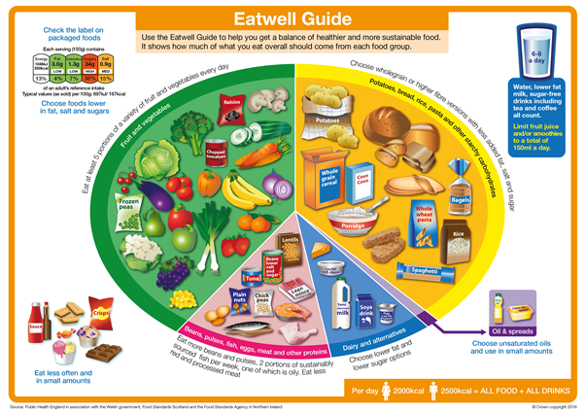

Within the formal curriculum-
- EYFS: regular tasting times and theme related cookery

- KS1 Science is based on the primary curriculum

- KS1 children have cookery lessons where they prepare different items

- Cross-curricular work

- PSHE

- Events led by Norse e.g. making smoothies, scones, fruit salad

Extra-curricular activities:

- Special events, such as Food Week, Healthy Living Week
- Assemblies/events led by Norse
- Cookery club

Inclusion.
Children with dietary needs are accommodated in all areas of school life including school dinners and teaching and learning activities. Parents/carers provide information regarding their child’s particular needs and alternative food choices are chosen together.

Continuous Professional Development
Staff and governors will be encouraged to attend relevant courses regarding healthy eating and food hygiene.

Partnerships- who we work with on food issues in schools
• School Council
Class and School Councils provide a voice for the children to make decisions on food choices.

• How we work with Parents and Carers
Parents/carers are kept informed of events to promote healthy eating and how they can actively support their child’s learning. Lunches/snack information is included in the induction pack for Nursery and Reception families.
From time to time Parents/carers are invited to lunch with their child. This helps to increase their awareness of what school lunchtimes entail and to actively partake.

• Role of the Governors
The governing board is involved in adopting policies regarding food and monitoring
and evaluating their implementation
From time to time Governors are invited to lunch with the children. This helps to increase their awareness of what school lunchtimes entail and to actively partake in monitoring healthy eating.

Review:
This policy will be reviewed every 3 years.

