Calculation Policy 2022- 2025

Rationale
Our school follows the CPA approach and firmly believes that using concrete manipulatives develops children’s mathematical understanding.
This policy demonstrates the formal recordings/calculations that our school supports and shows how they are developed as children progress throughout our school. We expect children to use a wide range of concrete manipulatives and record their work using pictures alongside those that are provided.
At Dereham Church Infant and Nursery School, we are aware that whole school policies can ensure consistency of approach, enabling children to progress stage by stage through models and representations they recognise from previous teaching, allowing for deeper conceptual understanding and fluency.
Number sense
At the end of EYFS, we aim for all our children to have a secure number sense. We define number sense as:
- Knowing numbers at least to 20
- Knowing that number names are in a particular order
- Linking numerals with amounts/objects
- Counting tangible objects and then progressing to counting abstract
- Counting in order
- Knowing that the final number counted is the total
- Recognising a group of objects and estimating
- Knowing how to find a total of numbers
- Recognising that a total is the same even if e.g. colours or the layout have changed
- Knowing a group of objects is more than or less than through comparison
- Recognising number patterns, pairs or bonds
- Recognising that a total can contain other numbers e.g. 6 can be made from 5 and 1
- Understanding the difference between numbers e.g. 15 is not the same as 51

Addition
Children will often first experience addition through counting rhymes/ songs and problem solving through play.
They will then begin to use 5 frames to place objects onto. This will help to identify one more, compare amounts and find totals within 5.

This will progress into using 10 frames

Children will start to add by combining 2 sets. They will count one set, then the other set. Combine the sets and count them altogether, starting at 1. This is called aggregation.
6 + 3 = 9

The children will then be taught to combine 2 sets They will count on from the total of the first set. This is called augmentation.
6 + 3 = 9

Bridging through 10
Children will be taught what happens to numbers when adding with a total that bridges through 10.
7 + 5 =

7 + 5 is decomposed into 7 + 3 + 2. The bead string illustrates ‘how many more to the next multiple of 10?’ then ‘if we have used 3 to get to 10 how many more do we need to add on?’
Children will learn that when adding 9 and 11 they add on 10 and then adjust by removing 1 or adding a further 1 more.
This is called compensation.
8 + 9

8 + 11

Children will then progress into using Dienes (base 10 equipment). They will create 2 sets using partitioning skills and then combine them. Children will be encouraged to count on from the first set, avoiding counting from 1.
Once children are confident with the above they will be introduced to exchanging. When the ones are greater than 10 they can be exchanged for a 10 rod.

Next children will work pictorially to solve a calculation.

Children will be taught how to add using a hundred square- jumping down for adding tens and across for adding ones.
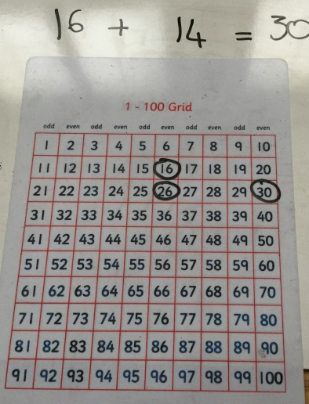

Number lines will be used to teach addition too. They can be used to jump on and can be used for children to develop their partitioning understanding if they are not ready to progress onto blank number lines.

Children will progress to using the blank number line method. When adding on a number line jumps should always move to the right. Children will partition the number that they are adding. They will then draw individual jumps for both the tens and ones

Children will then draw individual jumps for tens and a single jump for the ones.

Lastly children will draw a single jump for the tens and a single jump for the ones

Building on all of the children’s prior learning, the partitioning method will be taught.

The same method would be used to bridge through 10.

Children must develop an understanding of the commutative law and that starting with the largest number works best.
38+25=63
25+38=63

It is important to teach the children that the = sign is a sign of equivalence. Children must experience the equals sign in different positions. Balancing scales can be used to help children explore the idea that both sides of a calculation must balance.
5 = 3 + 2
7 + 3 = 10 so 7 = 10 - 3

Subtraction
Most children will first encounter subtraction through number rhymes/songs and problem solving through play.
Children are introduced to subtraction by using a range of objects and physically taking them away. This is called the separation model.

Children are taught to select 2 quantities and compare them to find the difference. This is called the comparison model.

Children will be taught what to do when the numbers that are being subtracted bridge through 10.
12 – 7 is decomposed in 12 – 2 – 5
The bead string illustrates ‘from 12 how many to the last/previous multiple of 10?’ then ‘if we have used 2 of the 7 we need to subtract, how many more do we need to count back?’

Children will learn that when subtracting 9 and 11 they subtract 10 and then adjust by removing 1 or adding a further 1 more.
This is called compensation.
18 - 9

18 – 11

Children will be taught how to subtract using a hundred square- jumping up for subtracting tens and across (to the left) for subtracting the ones.
67 – 26 =

Number lines will be used to teach subtraction too. They can be used to jump on and can be used for children to develop their partitioning understanding if they are not ready to progress onto the blank number line methods.
Children will use their partitioning knowledge to create the 2 numbers in the calculation with dienes. They will then remove the smaller quantity from the larger set.
46 – 23 =
Children will move on to recording this pictorially.

Next children will be taught how to exchange (when the ones are greater than 10) during subtraction. Dienes will be used to enable the children to physically exchange the tens for ones.
52 – 27 =
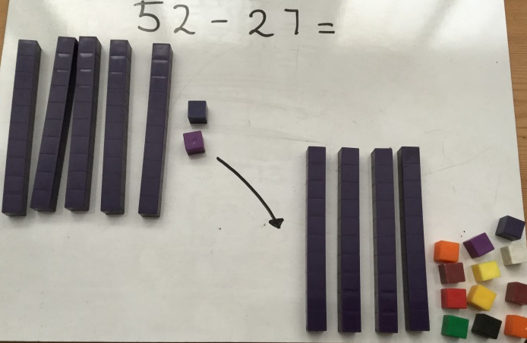

They will then be taught to record this pictorially.
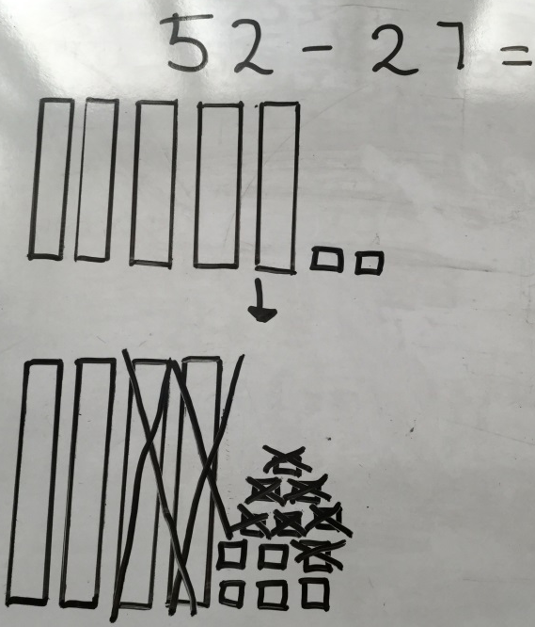

Children will progress to using the blank number line method. When subtracting on a number line jumps should always move to the left. Children will partition the number that they are subtracting. They will then draw individual jumps for both the tens and ones

Children will then draw individual jumps for tens and a single jump for the ones.
Lastly children will draw a single jump for the tens and a single jump for the ones

Multiplication
It is important that children understand that the inverse of multiplication is division.
Children learn doubling facts throughout their time at our school. They will be taught to use these known facts to double larger 2 digit numbers, e.g. double 16 is double 10 + double 6.
Children’s introduction to multiplication will be through counting in multiples of 2, 5 or 10. The use of manipulatives will help them to grasp this concept more quickly.
When children leave our school in Year 2 we expect them to be able to recite the 2,3, 5 and 10 times tables.
2, 4, 6, ..

5, 10, …

10, 20, 30, …

Children will then move on to recognising multiplication as repeated addition.
2+2+2+2= 8 or 2x4= 8 or 4 lots of 2 =8

Children will learn that repeated addition can be shown using objects, numberlines and beadstrings.

Children will be taught that the x symbol means multiply, times groups of and lots of.
This will then develop using counters or dienes and placing them into groups/lots of…
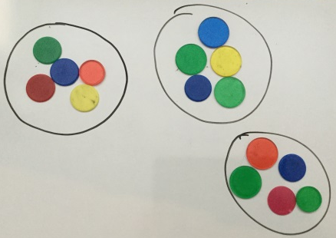
5x3=

As children become more confident this will be recorded pictorially

Children will then be introduced to using arrays to model a multiplication calculation.
This model demonstrates commutativity clearly, that 5x3 has the same total as 3x5.

Commutativity can also be shown on a numberline
3x5=15
5x3=15

Once children are confident with the above methods they can use the blank numberline method to answer a multiplication calculation.
6x4=?

Division
It is important that children understand that division is the inverse of multiplication. Therefore it is also the inverse of doubling. Children must learn and be able to recall halving facts.
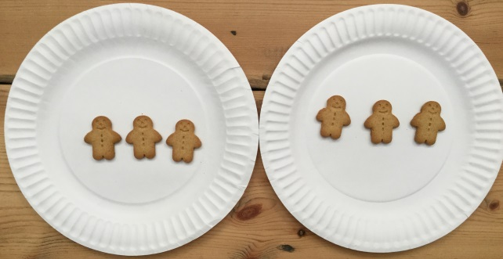
Division is introduced by sharing into equal groups using concrete objects/manipulatives. This could happen during play and problem solving situations particularly in the EYFS.

6 gingerbread men shared with 2 children means that the children get 3 each.
Fractions are included within teaching division because they are formed by separating a whole into equal parts.

Finding half of a quantity.
Half of 8 is 4
8 ÷ 2 = 4

Finding ¼ of a quantity
Half of 8 is 4
Half of 4 is 2

Finding a fraction of a quantity can be completed by using manipulatives. Our children are then taught that this could be solved pictorially too.
Find ¼ of 8.
Children will know that they need to ‘share’ the number into 4 parts. So they will draw a box with 4 parts.
They will then share eight equally into the boxes.

They will then find the total in one box. This will give the answer.

Children must then find ½ of a shape. This could be introduced by folding a piece of paper with a shape drawn on.

Then find ¼ of a shape.

Another form of division is grouping. This will be introduced by asking children to physically get into groups of 3, 5, etc.

9 children into groups of 3
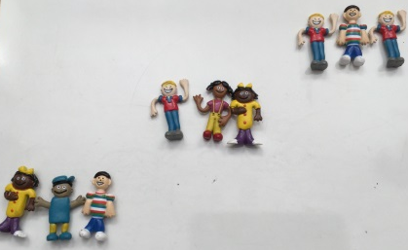

This will then develop into using pictures to group.
15 ÷ 3 = 5
It is important to teach that when grouping we count the number of groups that you have made.
E.g. How many groups of 3 are there in 15?

Children will then learn to record pictorially the sharing method.
It is important to teach when sharing that we count the number of objects in each group. Ensure careful counting as the number in each group needs to be the same otherwise this doesn’t demonstrate sharing equally.
18 ÷ 6 = ?

So 18 shared between 6 makes 3.
Division is also taught as repeated subtraction using a bead string and a number line.
12 ÷ 3 can be seen as how many 3s in 12?

Finally, after lots of learning children begin to understand that not all numbers can be shared equally and there will sometimes be some left over, these are called remainders.

Children will be able to create 4 calculations, using the inverse to state the related facts.
3 x 4 = 12
4 x 3 = 12
12 ÷ 4 = 3
12 ÷ 3 = 4

