Religious Education and Worldviews

Knowledge Organiser to support the Norfolk Agreed Syllabus

Year Group: 1

Enquiry: 3

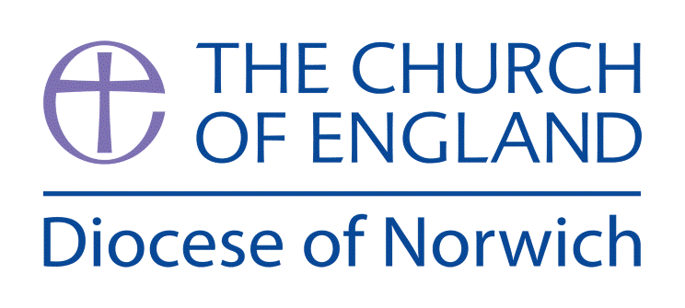

**What do Jews remember on Shabbat?**

**(Intention) What we intend to cover in our learning: (Topic web of concepts here)**

Session 1:Explore the Jewish story of Creation- video, drama, artwork, music. Look at the image and read the text to tell the creation story from this good quality article [www.chabad.org/library/article_cdo/aid/246605/jewish/Creation-of-the-World.htm](http://www.chabad.org/library/article_cdo/aid/246605/jewish/Creation-of-the-World.htm) ask the children to say I wonders from the story and not these down.

Session 2: Introduce what Shabbat is to the children, why Jews celebrate it each week and explore the artefacts associated with Shabbat. Use <https://bje.org.au/knowledge-centre/explained-for-kids/shabbat/shabbat-symbols-objects-explained-for-kids/> to explore each artefact. Have a go at making them out of clay and explain their use and symbolism.

Session 3: Children could think of two activities that Jews cannot do during Shabbat and two activities that they are allowed to do and draw pictures of them. They could discuss what they often do on Saturdays and identify which activities Jewish children would be allowed to do.

Session 4: Invite a member of the Jewish Community in to talk about Shabbat. There are three Jewish communities in Norfolk, Norwich Hebrew Congregation, Norwich Liberal Jewish Community, and West Norfolk Jewish Community. There is only one synagogue, the Norwich Hebrew Congregation Synagogue at 3 Earlham Road.

Session 5: Discuss why rest is important, how we rest and how this relates to Jews and the creation story. Children to imagine the story without rest – why might have happened? What would happen if everything was made in a rush or in one day? Children to explore these ideas by retelling, acting or drawing the stories in these contexts.

Session 6: Write/draw how you rest and compare with the Jewish traditions you have learned about.

**(Implementation) Key words I will use and need to know:**

Candles Challah Bread Creation

Jew Jewish Judaism Kiddush Cup

Menorah Shabbat Synagogue Zemirot

**(Implementation) Key information we will learn:**

* The Jewish story of creation and relate it to observing Shabbat.
* Jews believe in one God and that He is the creator.
* Shabbat is celebrated as a weekly tradition for Jewish families.
* The symbolism of the key artefacts used during Shabbat:
  + Candles – are lit before Shabbat to create peace in the home
  + Challah Bread – a special plaited bread to show how Jews love Shabbat
  + Kiddush Cup – a special goblet that holds the wine that is blessed for Shabbat
  + Zemirot – the special songs sung at the table for Shabbat

**(Implementation) Things to do and find out at home:**

* **Find out more about the main artefacts and symbols of shabbat at this website:** [**https://bje.org.au/knowledge-centre/explained-for-kids/shabbat/shabbat-symbols-objects-explained-for-kids/**](https://bje.org.au/knowledge-centre/explained-for-kids/shabbat/shabbat-symbols-objects-explained-for-kids/)
* **Design your own Challah Bread for Shabbat – think about the pattern of plaits you might use.**
* **Listen and learn some of the some of the songs sung at Shabbat here:** [**https://youtu.be/EHrIizIy-S8**](https://youtu.be/EHrIizIy-S8)

**(Implementation) Some key information you can find more out about:**

* The Jewish story of creation and relate it to observing Shabbat. Watch the Sesame Street video about this story - <https://youtu.be/lre-LLz-UzE>
* Shabbat is celebrated as a weekly tradition for Jewish families. This BBC video explains more - [www.bbc.co.uk/programmes/p0114xpt](http://www.bbc.co.uk/programmes/p0114xpt) and [www.bbc.co.uk/programmes/p01151nt](http://www.bbc.co.uk/programmes/p01151nt) and [www.bbc.co.uk/programmes/p01151n6](http://www.bbc.co.uk/programmes/p01151n6)
* How Shabbat is celebrated in a synagogue can be viewed here: [www.bbc.co.uk/programmes/p0115jms](http://www.bbc.co.uk/programmes/p0115jms)

**(Impact) What we will aim to do at the end of our learning:**

By the end of our learning we will

* Retell the Jewish story of Creation.
* Give an example of how Jews use the day of rest from the story of the creation to guide their daily lives.
* Recognise that the practice of Shabbat shows a strong relationship between Jews people and God.

**(Impact) The RE Age Related Expectations we will cover and be assessed against:**

**Theology**

1. **Where beliefs come from** Give a clear, simple account of at least one narrative, story or important text used by at least one religion or worldview.

**C, How beliefs relate to each other** Recognise that narratives, stories and texts used by at

least one religion or worldview contain beliefs.

**D. How beliefs shape the way believers see the world and each other** Give an example

of how Jews use beliefs to guide their daily lives