Religious Education and Worldviews

Knowledge Organiser to support the Norfolk Agreed Syllabus

Year Group: 2

Enquiry: 3

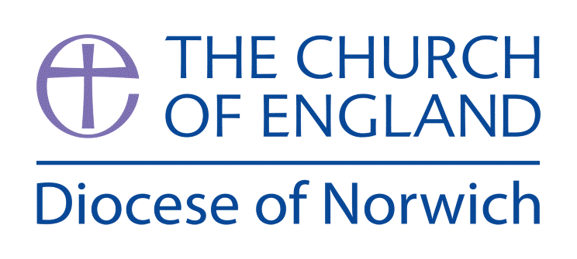

**How do Christians belong to their faith family?**

**(Intention) What we intend to cover in our learning: (Topic web of concepts here)**

Session 1:Discuss the different groups/families they belong to and how they know and how other people will know. The importance of worshiping together on a Sunday. Look at images to do with Christian worship and ask the children to discuss, raise questions and comments, A good resource for this is Picturing Christianity.

Session 2: Explore what is a First Communion, Christenings and Baptisms show Christians belong to their faith family. Go to your local church and ask your vicar to walk through or undertake a mock baptism in church. Explaining each stage. What do the children notice, what is important? Why?

Session 3: Explore how artefacts (font/christening candles/chalice and paten) are used to show Christians belong to their faith family. Look at how artefacts (prayer/hymn book) are used to show Christians belong to their faith family through worship. A good video for this is: [www.bbc.co.uk/bitesize/clips/zm87tfr](http://www.bbc.co.uk/bitesize/clips/zm87tfr)

Session 4: Explore the use of light and water in both infant and adult baptism/christening. Research the different symbols (cross/fish) that show belonging. Ask the children to design their own symbols.

Session 5: Think about why prayer might be used in worship that welcomes a new member to the community. Look at different version, a good website for this is: <https://churchofenglandchristenings.org/prayers/> Create a prayer to highlight the importance of being a part of a religious family

Session 6: Look at how he church is a group of people/faith family not only a building. A good website for information is: [www.patheos.com/blogs/markdroberts/series/what-is-a-church/](http://www.patheos.com/blogs/markdroberts/series/what-is-a-church/) a good video for children to use is: <https://youtu.be/5cCLbiXj1y8> Can the children draw what they think a church is and the people that make a church e.g. vicar, organist, choir, readers, congregation – the different groups e.g. Mothers Union etc.

Session 7: Pose the question - How using the name Christian means they belong to their faith family? Ask the children to draw / write/ discuss how this is represented in the special services, symbols and people involved.

**(Implementation) Key words I will use and need to know:**

Baptism Belong Belonging Chalice Christening Communion Faith Font Paten Worship

**(Implementation) Key information we will learn:**

* The importance of worshiping together on a Sunday.
* How First Communion, Christenings and Baptisms show Christians belong to their faith family.
* How artefacts (font/christening candles/chalice and paten) are used to show Christians belong to their faith family.
* How artefacts (prayer/hymn book) are used to show Christians belong to their faith family through worship.
* The use of light and water in both infant and adult baptism/christening.
* The different symbols (cross/fish) that show belonging.
* The church as a group of people/faith family not only a building.
* How using the name Christian means they belong to their faith family.

**(Implementation) Things to do and find out at home:**

* **Find out about different sorts of Christian churches from around the world and make a fact file.**
* **Visit your local church and find out what groups and activities it undertakes – this is what a church is! Make a list or take pictures to talk to the class about your visit.**
* **Write a special article for your local church magazine or draw a picture representing how important a church can be in its local community. What would it be like without the church and the work it does?**

**(Implementation) Some key information you can find more out about:**

* The importance of worshiping together on a Sunday. More information here: [www.ligonier.org/blog/why-christians-worship-sunday/](http://www.ligonier.org/blog/why-christians-worship-sunday/)
* How First Communion, Christenings and Baptisms show Christians belong to their faith family. More info on first communions can be found here: <https://catholicexchange.com/tradition-and-the-meaning-of-first-holy-communion> and christenings here: [www.bbc.co.uk/bitesize/guides/znqck2p/revision/3](http://www.bbc.co.uk/bitesize/guides/znqck2p/revision/3)
* The different symbols (cross/fish) that show belonging. More information can be found here: [www.learnreligions.com/christianity-symbols-illustrated-glossary-4051292](http://www.learnreligions.com/christianity-symbols-illustrated-glossary-4051292)

**(Impact) What we will aim to do at the end of our learning:**

By the end of our learning we will

* Identify how Christians beliefs impact on their worship and sense of belonging.
* Identify some Christians symbols and artefacts.
* Identify different ways in which Christians show they belong to their faith family.
* Recognise that some people call themselves Christians.

**(Impact) The RE Age Related Expectations we will cover and be assessed against:**

**Social Human Sciences**

1. **The diverse nature of religion**

Recognise the names of different religions, religious beliefs and worldviews and use them correctly.

1. **Diverse ways in which people practice and express beliefs**

Identify evidence of religion and belief especially in the local area.

1. **The ways in which beliefs shape individual identity, and impact on communities and society and vice versa**

Identify ways in which beliefs can have an impact on a believer’s daily life, their family or local community.