Religious Education and Worldviews

Knowledge Organiser to support the Norfolk Agreed Syllabus

Year Group: EYFS

Enquiry: 1

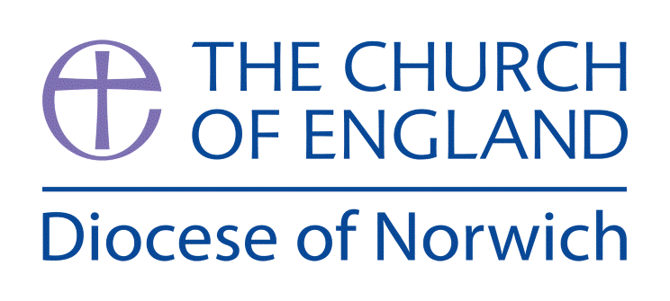

**Why do Christians put a cross in an Easter Garden?**

**(Intention) What we intend to cover in our learning: (Topic web of concepts here)**

Session 1 and 2:

* Explore the concept of Easter with he children – what do they know? Do they know what happened? What do they think it means?
* Encourage the children to ask questions and reflect on their thoughts.
* Look at images linked to Easter and get the children to discuss, question and explore them. (<https://pixabay.com/images/search/religious%20easter/> )

Session 3,4 and 5:

* Explore the Easter story – retell it from a Children’s Bible, watch it on a video clip ([www.bbc.co.uk/teach/class-clips-video/religious-studies-ks1-the-christian-story-of-easter/zhgv47h](http://www.bbc.co.uk/teach/class-clips-video/religious-studies-ks1-the-christian-story-of-easter/zhgv47h))
* Plot the main events from Palm Sunday to Easter Sunday.
* Explore the symbols of the cross, palm leaves, egg (rock in front of the tomb)
* Look at the traditions of Easter today - <https://youtu.be/vpV6jII2VO4>
* Children could make Easter cards with pictures of Easter on them, make hot cross buns, make an Easter Garden in a tough spot or learn easter songs .

Session 6:

* Explore how Easter is directly connected to Christian’s believe Jesus died so people would be forgiven by God for things they should say, do or think.
* Easter is about forgiveness, sacrifice and a new start. Ref to Understanding Christianity Unit F3 pg5 for more ideas on how to explore this.

Session 7:

* Explore the idea of Jesus was sent to help Christians.
* How might the children learn from the Easter story to help others today?
* Look at the story of the Good Samaritan from the Bible (<https://youtu.be/aSfm2xdKau4>)
* Can the children think about how they might help people today – what might they do? Who might they ask and why?

**(Implementation) Key words I will use and need to know:**

God Jesus Easter Forgiveness

Cross Holy Week Palm Sunday Love

Hosanna Good Friday Sorry Sacrifice

**(Implementation) Key information we will learn:**

* **The events of Jesus last week on earth (Holy week).**
* **Palm Sunday was when Jesus entered Jerusalem on a donkey and people called Hosanna to him.**
* **Easter is a period of time longer than one day.**
* **Easter is the most important event in the Christian calendar.**
* **Easter is linked to forgiveness, love and sacrifice.**

**(Implementation) Things to do and find out at home:**

* **Find out about the Easter Story by watching this video with your parents:** [**https://youtu.be/1RWqVX6_Hno**](https://youtu.be/1RWqVX6_Hno)
* **Make a donkey mask to remember the donkey that carried Jesus into Jerusalem on Palm Sunday.**
* **Make an Easter garden at home.**
* **Listen to the Easter story here:** [**https://youtu.be/HL8R158Ujp4**](https://youtu.be/HL8R158Ujp4)

**(Implementation) Some key information you can find more out about:**

* **The events of Jesus last week on earth (Holy week) can be explored by downloading the resource guide from Wrstminster Abbey here:** [**www.westminster-abbey.org/teaching-resources/holy-week-a-short-guide-for-primary**](http://www.westminster-abbey.org/teaching-resources/holy-week-a-short-guide-for-primary)
* **Palm Sunday and what it means to Christian’s can be listened to on the BBC Schools radio assembly here:** [**www.bbc.co.uk/teach/school-radio/assemblies-ks1-ks2-easter-palm-sunday-dan-the-donkey/zsc2dp3**](http://www.bbc.co.uk/teach/school-radio/assemblies-ks1-ks2-easter-palm-sunday-dan-the-donkey/zsc2dp3)
* **What is Easter can be unpacked in this BBC resource:** [**www.bbc.co.uk/bitesize/topics/ztkxpv4/articles/z4t6rj6**](http://www.bbc.co.uk/bitesize/topics/ztkxpv4/articles/z4t6rj6)
* **Easter is linked to forgiveness, love and sacrifice, you can find out more about these themes here:** [**www.brf.org.uk/resources/?tid=All**](http://www.brf.org.uk/resources/?tid=All)

**(Impact) What we will aim to do at the end of our learning:**

By the end of our learning we will

* Christians remember Jesus’ last week at Easter.
* Jesus’ name means ‘He saves’
* Christians believe Jesus came to show God’s love.
* Christians try to show love to others.

**(Impact) The RE Age Related Expectations we will cover and be assessed against:**

The Age Related Expectations do not apply to EYFS and it is suggested assessment is made using the foundation stage profile areas of learning instead. The ELGs that can be used include:

* Communication and language development
* Personal, social and emotional development
* Literacy
* Understanding the world
* Expressive arts and design