Religious Education and Worldviews

Knowledge Organiser to support the Norfolk Agreed Syllabus

Year Group: 1

Enquiry: 5

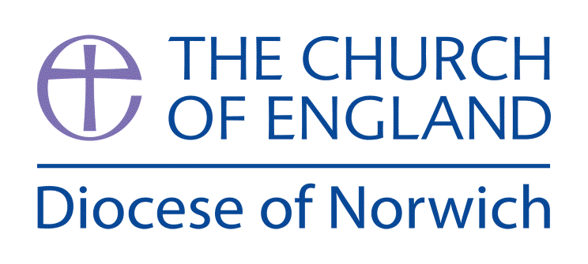

**How did the universe come to be?**

**(Intention) What we intend to cover in our learning: (Topic web of concepts here)**

Session 1:Introduce the Big Question and discuss the word Universe – what does it mean. Look at images of the universe (star constellations) then drill down to planets and an to earth. What I wonders do these raise? Encourage the pupils to use their senses to explore the world around them and ask questions, e.g. go outside and look around, what do they notice, what interests them? How do they think everything was made?

Session 2: Explore one of the Hindu stories of creation (eg, Vishnu and the Lotus Flower). A good version of this can be accessed here: <https://youtu.be/ixY4pfb4iuE> What does this story tell us about what Hindus believe about creation? What do the children find interesting? Why? Ask the children to retell the story using some of the key vocabulary on this knowledge organiser.

Session 3: Explore the Christian accounts of creation in Genesis 1-2. A good version of this can be accessed here: <https://youtu.be/vmzYaCFHSX0> What does this story tell us about what Christians believe about creation? What do the children find interesting? Why? Ask the children to retell the story using some of the key vocabulary on this knowledge organiser.

Session 4: Spend this session comparing the two creation stories heard and the similarities and differences. Which do the children think is more realistic and why?

Session 5: Consider our own environment; how can we look after it? How might Christians and Hindus look after it? Consider using some of the stewardship resources from the Our World: Our Planet EcoRE booklet published by the diocese and available here: <https://www.dioceseofnorwich.org/app/uploads/2021/05/Eco-School-Booklet-2021-v5.pdf>

Session 6: Ask the children to write, draw or role play their own creation story. Thinking about the language of the two stories they have heard. What would they include and explain int heir story? Why? What order would they set their story in?

**(Implementation) Key words I will use and need to know:**

Brahma Care Christian Creation

God Hindu Origin Universe

Vishnu

**(Implementation) Key information we will learn:**

* The creation stories within Christian and Hindu traditions.
* Non-religious ideas about how the origin of the universe.
* Reasons why people look after the world.
* Examples of how people look after the world.

**(Implementation) Things to do and find out at home:**

* **Draw a picture of the world – what would you include in it if you were creating it from scratch?**
* **Look at different creation stories from around the world – good websites are:** [**https://historycollection.com/16-incredible-ancient-creation-stories-from-around-the-world/**](https://historycollection.com/16-incredible-ancient-creation-stories-from-around-the-world/)
* **Explore some of the rituals and practices of Hindus here:** [**www.bbc.co.uk/bitesize/topics/zh86n39/articles/zmpp92p**](http://www.bbc.co.uk/bitesize/topics/zh86n39/articles/zmpp92p)

**(Implementation) Some key information you can find more out about:**

* The creation stories within Christian and Hindu traditions. A good BBC video for Hindu creation stories can be found here: [www.bbc.co.uk/programmes/p02gj232](http://www.bbc.co.uk/programmes/p02gj232) Traditions and beliefs linked to Hindu creation stories can be researched here: [www.history.com/topics/religion/hinduism](http://www.history.com/topics/religion/hinduism)
* Non-religious ideas about how the origin of the universe. A good Humanist presentation on this (for teachers knowledge) is: http://concordareahumanists.org/sites/concordareahumanists.org/files/[Final.Hum.Creat.Story.12.5.18 (concordareahumanists.org)](http://concordareahumanists.org/sites/concordareahumanists.org/files/Final.Hum_.Creat_.Story_.12.5.18.PDF)
* Reasons why people look after the world. Explore the Our World: Our Planet teaching resource from the Diocese of Norwich - <https://www.dioceseofnorwich.org/app/uploads/2021/05/Eco-School-Booklet-2021-v5.pdf>

**(Impact) What we will aim to do at the end of our learning:**

By the end of our learning we will

* Ask at least one question about the origin of the universe.
* Give a simple reason, using the word ‘because’, for the origin of the universe.
* Know that, for some people, religions provide an answer to the question of the origin of the universe (creation stories).
* Know that beliefs about the origin of the universe influence how individuals treat the world around them.

**(Impact) The RE Age Related Expectations we will cover and be assessed against:**

**Philosophy**

1. **The Nature of knowledge, meaning and existence** Ask questions about the world around them and talk about these questions. Begin to make connections between using their senses and what they know about the world around them.
2. **How and whether things make sense** Give a simple reason using the word ‘because’ when talking about religion and belief.
3. **Issues of right and wrong, good and bad** Using religious and belief stories to talk about how beliefs impact on how people behave