Religious Education and Worldviews

Knowledge Organiser to support the Norfolk Agreed Syllabus

Year Group: 2

Enquiry: 5

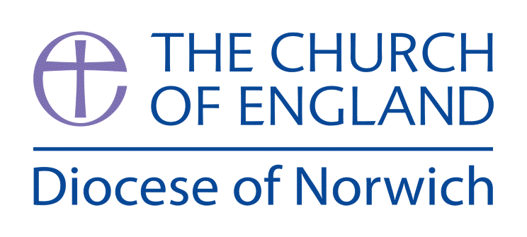

**Why do people have different views about the ideas of God?**

**(Intention) What we intend to cover in our learning: (Topic web of concepts here)**

Session 1: Look at the big question. What do the children understand God to be? Ask them to draw and write about the image they have of God, where did they get their ideas from? How do they know? Where might they find clues out about God? Compare each child’s ideas then introduce the idea different religions have different ideas about God and some people do not believe there is a God and they are known as atheists.

Session 2: Introduce the key vocabulary, what does each word mean and how might we use it? Make a working wall of the key vocab, what it means and examples of how it might be used.

Session 3: Analyse different images of God and compare the beliefs around them, looking at similarities and differences (moving onto how people view what God is like as a being). Good images to use can be found here in this National Geographic video: <https://youtu.be/LvL3YXa0n2M>

Session 4: Consider key words to describe God and how they communicate beliefs of those who use them, eg, the 99 Names of Allah, the Mool Mantra. A good resource is [www.understandingchristianity.org.uk/wp-content/uploads/2016/04/KS1_1.1_God_unit_WEB.pdf](http://www.understandingchristianity.org.uk/wp-content/uploads/2016/04/KS1_1.1_God_unit_WEB.pdf)

Session 5: Use True Tube to explore different people talking about how they view the idea of God. Make a comparison table to the different views and record these with he children.

Session 6: Read stories/prayers from different religious traditions and consider what they tell people about the idea of God. Some useful videos are: <https://youtu.be/ZrdlXOk_QdQ> <https://youtu.be/HW0DzGEoa1Y> <https://youtu.be/dv8dHsxjLd8> and <https://youtu.be/gGpKaoEQJl8>

Session 7: Look at Humanist views about God here: [www.bbc.co.uk/bitesize/topics/znk647h/articles/zmqpkmn](http://www.bbc.co.uk/bitesize/topics/znk647h/articles/zmqpkmn)

Another good resource is: [www.humanism.scot/wp-content/uploads/2015/09/Caring-for-our-world-primary-resources-from-HSS.pdf](http://www.humanism.scot/wp-content/uploads/2015/09/Caring-for-our-world-primary-resources-from-HSS.pdf)

Use this as comparative basis for the religious views of God previously explored. Ask the children to revisit their pictures from the first session. What do they now think about God and why? What has / has not changed?

**(Implementation) Key words I will use and need to know:**

Agnostic Allah Atheist Brahman

God Humanist Theist

**(Implementation) Key information we will learn:**

* The word ‘God’ is a name.
* The key beliefs about God from at least two different religions/worldviews.
* How a person’s behaviour is connected to their view of God.
* Two different stories/narratives that illustrate beliefs about God.

**(Implementation) Things to do and find out at home:**

* **Take time to explore the different views of God from Hindus, Christians, Muslims and Humanists. Help your child make some notes of the similarities and differences.**
* **Get your child to draw some of the things God might do.**
* **If your child could choose what God looked like and they could do – what would this be? Draw and write about their ultimate God at home.**

**(Implementation) Some key information you can find more out about:**

* The word ‘God’ is a name. More information on this can be accessed here: <https://en.wikipedia.org/wiki/God_(word)>
* How a person’s behaviour is connected to their view of God. A useful reference tool (not for children) can be accessed here: <https://quadrantinternational.net/musings/how-people-perceive-god/>
* Two different stories/narratives that illustrate beliefs about God, some good examples can be found in the following websites: <https://minethedepths.com/differences-between-two-genesis-creation-stories/>

<https://spiritualray.com/creation-stories-for-different-religions>

**(Impact) What we will aim to do at the end of our learning:**

By the end of our learning we will

* To give a reason why a member of at least one religious community might believe in God.
* To give a reason why a person might not believe in God.
* To give an example of what a member of a religious community might believe about God.
* Make connections between people’s beliefs of right and wrong and their belief about God.

**(Impact) The RE Age Related Expectations we will cover and be assessed against:**

**Philosophy**

1. **The Nature of knowledge, meaning and existence**

Talk about the questions a story or practice from a religion or worldview might make them ask about the world around them

Talk about what people mean when they say they ‘know’ something.

1. **How and whether things make sense**

Give a reason to say why someone might hold a particular belief using the word ‘because’